TC-PM-017
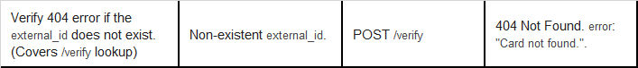
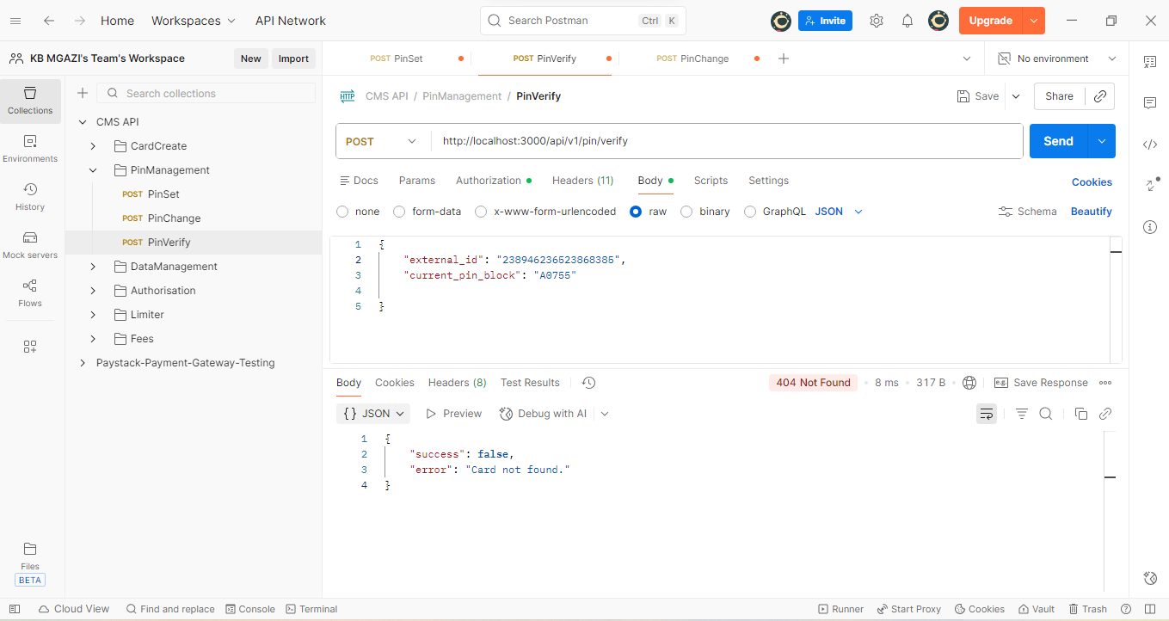
Request:
{
"external_id": "238946236523868385",
"current_pin_block": "A0755"

}
Response:
{
"success": false,
"error": "Card not found."
}

